January 2nd, 2022
Epiphany of Our Lord

Prelude
Welcome
Confession and Forgiveness
Blessed be the holy Trinity, ☩ one God,
who sends the word with angels,
who is made flesh among all peoples,
and who breathes peace on all the earth.
Amen.
In Christ, we are bold to name our sin and cry out for peace.

Silence is kept for reflection.
Holy God,
we confess our sin before you.
We replace compassion with competition.
We seek what is mighty while ignoring the meek.
We are quick to anger but slow to forgive.
We have not put on love in harmony with you.
Wrap us in the grace of your powerful Word.
Swaddle our hearts with your peace,
that all we do, in word or deed,
may reflect your love born among us.
Amen.

I bring you good news of great joy for all people:
God has come among us
in the child born of Mary, Christ the Lord.
☩ In Christ your sins are forgiven
and you are clothed in peace.
Amen.
Gathering Hymn: Gather Us In ELW 532, v. 1

Greeting & Prayer of the Day
The grace of our Lord, Jesus Christ, the love of God, and the communion of the Holy Spirit be with you all.
And also with you.
Let us pray.
Almighty and ever-living God, you revealed the incarnation of your Son by the brilliant shining of a star. Shine the light of your justice always in our hearts and over all lands, and accept our lives as the treasure we offer in your praise and for your service, through Jesus Christ, our Savior and Lord, who lives and reigns with you and the Holy Spirit, one God, now and forever.
Amen.

First Reading: Jeremiah 31:7-14

Thus says the Lord:
Sing aloud with gladness for Jacob,
and raise shouts for the chief of the nations;
proclaim, give praise, and say,
“Save, O Lord, your people,
the remnant of Israel.”
See, I am going to bring them from the land of the north,
and gather them from the farthest parts of the earth,
among them the blind and the lame,
those with child and those in labor, together;
a great company, they shall return here.
With weeping they shall come,
and with consolations I will lead them back,
I will let them walk by brooks of water,
in a straight path in which they shall not stumble;
for I have become a father to Israel,
and Ephraim is my firstborn.

Hear the word of the Lord, O nations,
and declare it in the coastlands far away;
say, “He who scattered Israel will gather him,
and will keep him as a shepherd a flock.”
For the Lord has ransomed Jacob,
and has redeemed him from hands too strong for him.
They shall come and sing aloud on the height of Zion,
and they shall be radiant over the goodness of the Lord,
over the grain, the wine, and the oil,
and over the young of the flock and the herd;
their life shall become like a watered garden,
and they shall never languish again.
Then shall the young women rejoice in the dance,
and the young men and the old shall be merry.
I will turn their mourning into joy,
I will comfort them, and give them gladness for sorrow.
I will give the priests their fill of fatness,
and my people shall be satisfied with my bounty,
says the Lord.

Word of God, Word of Life
Thanks be to God.

Psalm 72:1-7, 10-14

O God, give your anointed one your judgement –
and your justice.
Teach your chosen one to govern your people rightly
and bring justice to the oppressed.
The mountains will bring the people peace
and the hills justice!
Your anointed will defend the oppressed among the people,
save the children of the poor,
and crush the oppressor.
The reign of your anointed will endure
as long as the sun and moon –
throughout all generations.
The rule of the chosen one will be
like rain coming down on the meadow,
like showers watering the earth,
Justice will flower through the days, and profound peace,
until the moon be no more.
Tarshish and the Isles will offer gifts;
Arabia and Sheba will bring tribute.
All rulers will pay homage,
and all nations will serve your anointed.
Your anointed will resuce the poor when they cry out,
and the oppressed when there is no one to help them.
Your chosen one
will take pity on the lowly and the poor,
and will save their lives.
Your chosen one
will rescue them from all violence and oppression
and will treat their blood as precious.
Gospel: John 1:9-14

The Holy Gospel according to John the 1st chapter.

The true light, which enlightens everyone, was coming into the world.

He was in the world, and the world came into being through him; yet the world did not know him. He came to what was his own, and his own people did not accept him. But to all who received him, who believed in his name, he gave power to become children of God, who were born, not of blood or of the will of the flesh or of the will of man, but of God.

And the Word became flesh and lived among us, and we have seen his glory, the glory as of a father’s only son, full of grace and truth

Word of God for the people of God.
Thanks be to God.

Sermon Rev. Dr. Deb Allen

Hymn of the Day: Shine, Jesus, Shine TFWS 2173

A New Creed - Statement of Faith of the United Church of Canada

Please stand as you are able as we confess our faith in God together:

We are not alone
we live in God’s world.
We believe in God:
who has created and is creating,
who has come in Jesus,
the Word made flesh,
to reconcile and make new,
who works in us and others
by the Spirit.
We trust in God.
We are called to be the Church:
to celebrate God’s presence,
to live with respect in Creation,
to love and serve others,
to seek justice and resist evil,
to proclaim Jesus, crucified and risen,
our redeemer and our hope.
In life, in death, in life beyond death,
God is with us.
We are not alone.
Thanks be to God. Amen.

Joys & Concerns
Now is the time in our service to hear the joys and concerns of our community. If you have something you’d like to share, please raise your hand and an usher will bring a microphone to you. Please stand if you are able while sharing so that we can see who is speaking.

Prayers of the People

Joining our voices with the heavenly host and Christians throughout time and space, let us pray for the church, the world, and all in need.

A brief silence.

You created heaven and earth. Through your Spirit send your all-encompassing love over the cosmos. Bless the stars that guide our way and the night sky that invites the earth into slumber.
Merciful God,
receive our prayer.

You sent the magi to follow the star into an uncertain future. May all leaders and peoples seek your face, especially when paths are not clear, conflicts rage, tyrants oppress, and fear abounds.
Merciful God,
receive our prayer.

You sent your Spirit to dwell with Paul in prison. Send your Spirit to those who are imprisoned and enslaved. Give courage and wisdom for building roads that lead to justice and freedom.
Merciful God,
receive our prayer.

You sent the holy family to seek safety in a new land. Protect all who make similar journeys. Send your guiding Spirit to asylum seekers, refugees, and all who journey toward safety.
Merciful God,
receive our prayer.

Here other intercessions may be offered.

Rejoicing in your Word made flesh among us, we commend these prayers to you, confident of your grace and love made known to us in Jesus Christ, our Savior.
Amen.

Offering

Offering Prayer
Gracious God,
your Word-made-flesh brings harmony to the earth.
As we offer ourselves and these your gifts,
prepare us to receive the grace and truth
you offer at this table
and renew in us the song of your salvation,
in Jesus Christ our Savior.
Amen.

The Great Thanksgiving

The Lord be with you.

And also with you.

Lift up your hearts.

We lift them to the Lord.

Let us give thanks to the Lord our God.

It is right to give our thanks and praise.

It is indeed right, our duty and our joy, that we should at all times and in all places give thanks and praise to you, almighty and merciful God, through our Savior Jesus Christ. By the leading of a star he was shown forth to all nations; in the waters of the Jordan you proclaimed him your beloved Son, and in the miracle of water turned to wine he revealed your glory. And so, with all the choirs of angels, with the church on earth and the hosts of heaven, we praise your name and join their unending hymn:
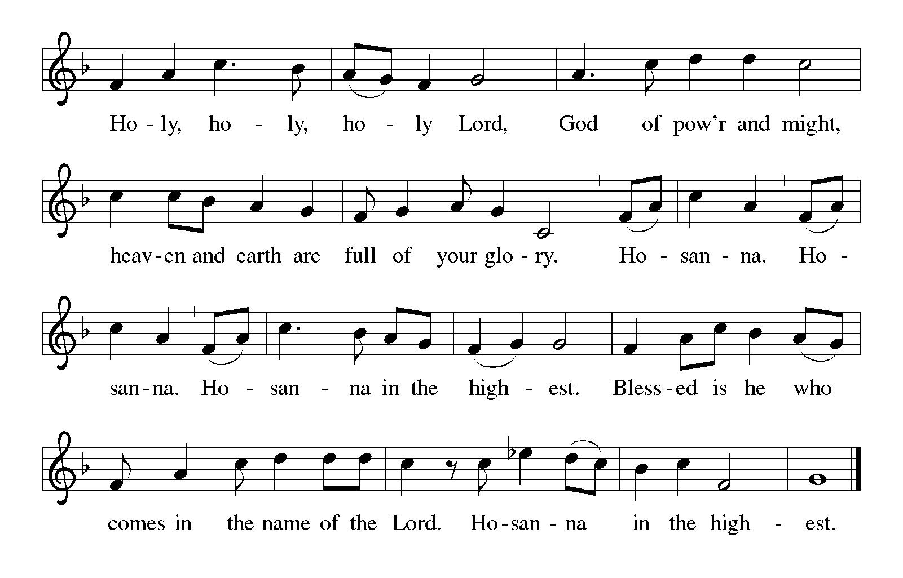

Holy One,
the beginning and the end,
the giver of life:
Blessed are you
for the birth of creation.
Blessed are you
for your promise to your people.
Blessed are you
in the prophets’ hopes and dreams.
Blessed are you
for Mary’s openness to your will.
Blessed are you for your Son Jesus,
the Word made flesh.

In the night in which he was betrayed,
our Lord Jesus took bread,
and gave thanks; broke it,
and gave it to his disciples,
saying: Take and eat:
this is my body, given for you.
Do this for the remembrance of me.

Again, after supper, he took the cup, gave thanks, and gave it for all to drink,
saying: This cup
is the new covenant in my blood,
shed for you and for all people
for the forgiveness of sin.
Do this for the remembrance of me.

Let us proclaim the mystery of faith:
Christ has died.
Christ is risen.
Christ will come again.

Gathered into one by the Holy Spirit, let us pray as Jesus taught us:

Our Father in heaven,
hallowed be your name,
your kingdom come,
your will be done,
on earth as in heaven.

Give us today our daily bread.
Forgive us our sins
as we forgive those
who sin against us.

Save us from the time of trial
and deliver us from evil.

For the kingdom, the power,
and the glory are yours,
now and forever. Amen.

Communion Instructions and Distribution

Prayer after Communion

We thank you, wondrous God, for Jesus,
God with us, in these gifts of bread and wine.
As we have shared this feast of love,
strengthen us to share your love with all the world.
In Jesus’ name we pray.
Amen.

Announcements (see end of worship bulletin)

Blessing

The God of hope
fill us with all joy and peace in believing,
so that we may abound in hope and love
by the power of the Holy Spirit,
through Christ Jesus, for whom we wait.
Amen.

Sending Song: This Little Light of Mine ELW 677
Dismissal
Go in peace. Rejoice in Christ our Savior!
Thanks be to God.

1140 Tucker Rd. Hood River, OR 97031
541-386-3993
www.hoodriverchurch.org

Church Office Hours
Closed on Fridays

Pastor Miranda Bermes-Goller
M-W 9-12, or by appointment
spiritofgracepastor@gmail.com

Jennifer Fowler, Office Assistant
Mon 9:30-2, Wednesday 9:00-2, Thursday 9:00-2
office@hoodriverchurch.com

Linda Boris, Pastoral Assistant
Tuesday 10-1

Announcements

Pastor Miranda is on vacation January 1-6
She will respond to emails when she gets back in town. Contact Jennifer or Linda in the office if you have a question that requires a more immediate response.

January Newsletter

Annual Meeting: January 16th
Our annual congregational meeting will be held on January 16th following worship. A letter was sent out with more details, and can also be accessed in the newsletter.

SPRC Meeting: January 9th
The Staff Parish Relations Committee will meet next Sunday following worship.

Attributions

Prayers & Liturgy from Sundays & Seasons, 2021 Augsburg Fortress
Gather Us In Text and music copyright © 1982 GIA Publications, Inc.
Shine, Jesus,Shine 1987 Make Way Music, admin. by Music Services in the Western Hemisphere
This Little Light of Mine Public Domain

